**BANK LOAN REPORT QUERY DOCUMENT**

1. **BANK LOAN REPORT | SUMMARY**

KPI’s:

Total Loan Applications

select count(ï»¿id) as total_application from financial_loan;

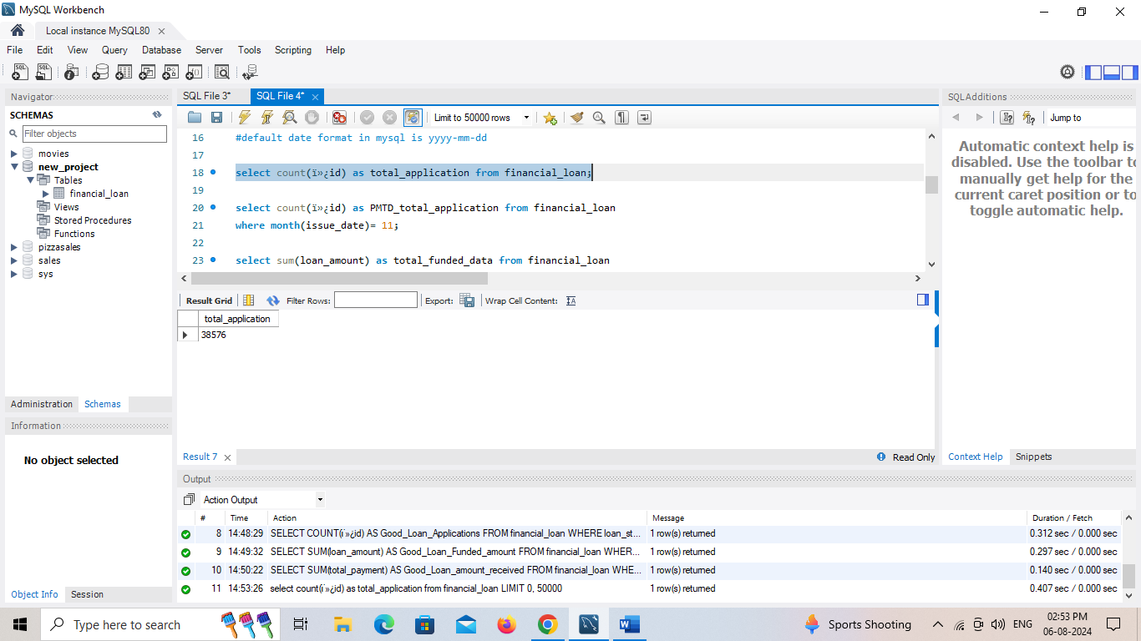

**MTD Loan Applications**

SELECT COUNT(id) AS Total_Applications FROM financial_loan

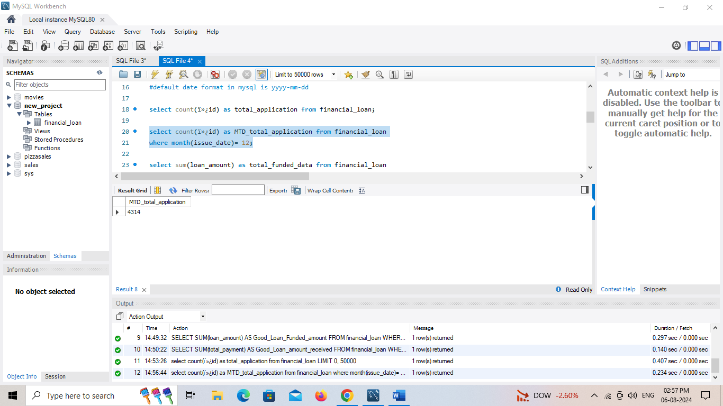WHERE MONTH(issue_date) = 12

**PMTD Loan Applications**  
SELECT COUNT(id) AS Total_Applications FROM financial_loan

WHERE MONTH(issue_date) = 11

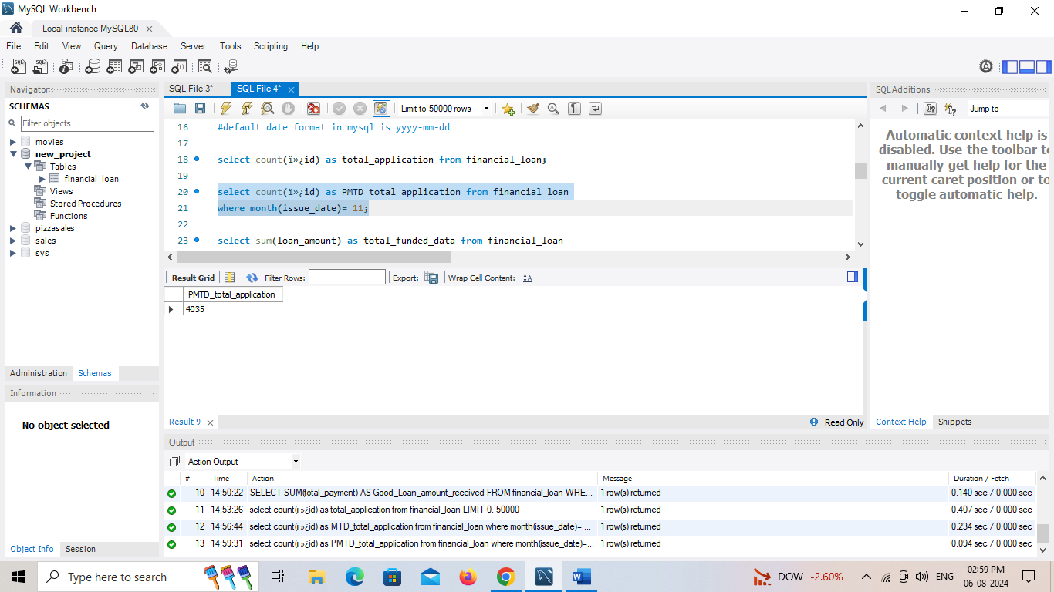

**Total Funded Amount**

SELECT SUM(loan_amount) AS Total_Funded_Amount FROM financial_loan



**MTD Total Funded Amount**

SELECT SUM(loan_amount) AS MTD_Total_Funded_Amount FROM financial_loan

WHERE MONTH(issue_date) = 12



**PMTD Total Funded Amount**

select sum(loan_amount) as PMTD_total_funded_data from financial_loan

where month(issue_date)= 11 and year(issue_date)=2021;



**Total Amount Received**

select sum(total_payment) as total_amount_received from financial_loan;



**MTD Total Amount Received**

select sum(total_payment) as MTD_total_amount_received from financial_loan

where month(issue_date)= 12 and year(issue_date)=2021;



**PMTD Total Amount Received**

select sum(total_payment) as PMTD_total_amount_received from financial_loan

where month(issue_date)= 11 and year(issue_date)=2021;



**Average Interest Rate**

SELECT AVG(int_rate)*100 AS Avg_Int_Rate FROM financial_loan



**MTD Average Interest**

SELECT AVG(int_rate)*100 AS MTD_Avg_Int_Rate FROM financial_loan

WHERE MONTH(issue_date) = 12 year(issue_date)=2021 ;



**PMTD Average Interest**

SELECT AVG(int_rate)*100 AS PMTD_Avg_Int_Rate FROM financial_loan

WHERE MONTH(issue_date) = 11 and year(issue_date)=2021;



**Avg DTI**

select avg(dti)*100 as avg_dti from financial_loan;



**MTD Avg DTI**

select avg(dti)*100 as MTD_avg_dti from financial_loan

WHERE MONTH(issue_date) = 12 and year(issue_date)=2021;



**PMTD Avg DTI**

select avg(dti)*100 as PMTD_avg_dti from financial_loan

WHERE MONTH(issue_date) = 11 and year(issue_date)=2021;



**GOOD LOAN ISSUED**

**Good Loan Percentage**

select

(count(case when loan_status= 'Fully Paid'or loan_status= 'Current' then ï»¿id end )*100)

/

count(ï»¿id) as Good_loan_percentage

from financial_loan;



**Good Loan Applications**

SELECT COUNT(ï»¿id) AS Good_Loan_Applications FROM financial_loan

WHERE loan_status = 'Fully Paid' OR loan_status = 'Current';



**Good Loan Funded Amount**

SELECT SUM(loan_amount) AS Good_Loan_Funded_amount FROM financial_loan

WHERE loan_status = 'Fully Paid' OR loan_status = 'Current';



**Good Loan Amount Received**

SELECT SUM(total_payment) AS Good_Loan_amount_received FROM financial_loan

WHERE loan_status = 'Fully Paid' OR loan_status = 'Current'



**BAD LOAN ISSUED**

**Bad Loan Percentage**

SELECT

(COUNT(CASE WHEN loan_status = 'Charged Off' THEN ï»¿id END) * 100.0) /

COUNT(ï»¿id) AS Bad_Loan_Percentage

FROM financial_loan;



**Bad Loan Applications**

SELECT COUNT(ï»¿id) AS Bad_Loan_Applications FROM financial_loan

WHERE loan_status = 'Charged Off';



**Bad Loan funded amount**

SELECT SUM(loan_amount) AS Bad_Loan_Funded_amount FROM financial_loan

WHERE loan_status = 'Charged Off';



**Bad Loan Amount Received**

SELECT SUM(total_payment) AS Bad_Loan_amount_received FROM bank_loan_data

WHERE loan_status = 'Charged Off';



**LOAN STATUS**

SELECT

loan_status,

COUNT(ï»¿id) AS LoanCount,

SUM(total_payment) AS Total_Amount_Received,

SUM(loan_amount) AS Total_Funded_Amount,

AVG(int_rate * 100) AS Interest_Rate,

AVG(dti * 100) AS DTI

FROM

financial_loan

GROUP BY

loan_status;

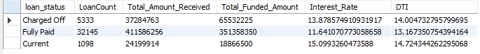

SELECT

loan_status,

SUM(total_payment) AS MTD_Total_Amount_Received,

SUM(loan_amount) AS MTD_Total_Funded_Amount

FROM financial_loan

WHERE MONTH(issue_date) = 12

GROUP BY loan_status

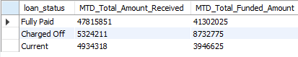

1. **BANK LOAN REPORT | OVERVIEW**

**MONTH**

select

MONTH(issue_date) AS Month_Munber,

monthname(issue_date) as month_name,

count(ï»¿id)AS Total_Loan_Applications,

SUM(loan_amount) AS Total_Funded_Amount,

SUM(total_payment) AS Total_Amount_Received

from financial_loan

GROUP BY MONTH(issue_date), monthname(issue_date)

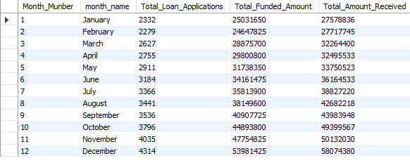ORDER BY MONTH(issue_date);

**STATE**

SELECT

address_state AS State,

COUNT(ï»¿id) AS Total_Loan_Applications,

SUM(loan_amount) AS Total_Funded_Amount,

SUM(total_payment) AS Total_Amount_Received

FROM financial_loan

GROUP BY address_state

ORDER BY address_state;

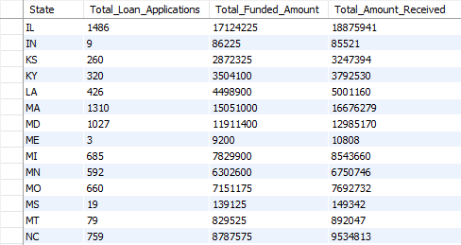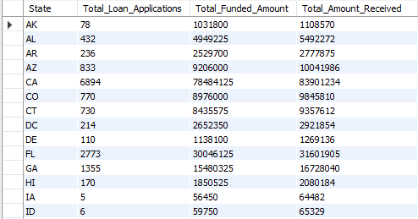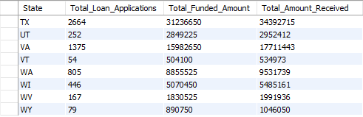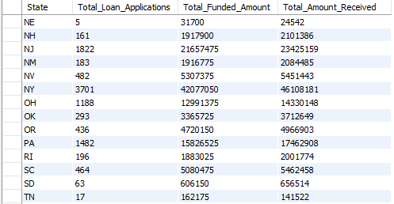

**TERM**

SELECT

term,

COUNT(ï»¿id) AS Total_Loan_Applications,

SUM(loan_amount) AS Total_Funded_Amount,

SUM(total_payment) AS Total_Amount_Received

FROM financial_loan

GROUP BY term

ORDER BY term;



**EMPLOYEE LENGTH**

SELECT

emp_length,

COUNT(ï»¿id) AS Total_Loan_Applications,

SUM(loan_amount) AS Total_Funded_Amount,

SUM(total_payment) AS Total_Amount_Received

FROM financial_loan

GROUP BY emp_length

ORDER BY emp_length;

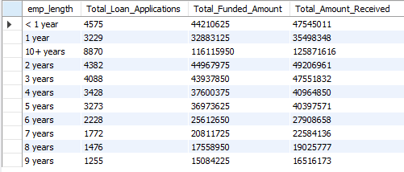

**PURPOSE**

SELECT

purpose,

COUNT(ï»¿id) AS Total_Loan_Applications,

SUM(loan_amount) AS Total_Funded_Amount,

SUM(total_payment) AS Total_Amount_Received

FROM financial_loan

GROUP BY purpose

ORDER BY purpose;

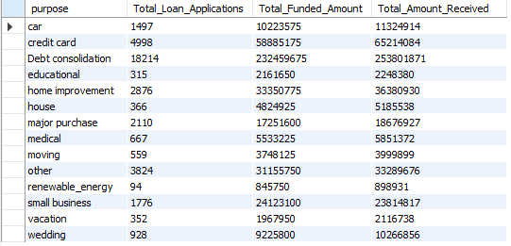

**HOME OWNERSHIP**

SELECT

home_ownership,

COUNT(ï»¿id) AS Total_Loan_Applications,

SUM(loan_amount) AS Total_Funded_Amount,

SUM(total_payment) AS Total_Amount_Received

FROM financial_loan

GROUP BY home_ownership

ORDER BY home_ownership;

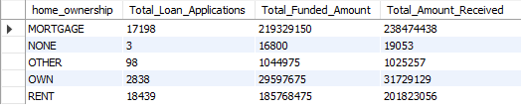

*Note: We have applied multiple Filters on all the dashboards. You can check the results for the filters as well by modifying the query and comparing the results.*

*For e.g*

*See the results when we hit the Grade A in the filters for dashboards.*

SELECT

purpose AS PURPOSE,

COUNT(ï»¿id) AS Total_Loan_Applications,

SUM(loan_amount) AS Total_Funded_Amount,

SUM(total_payment) AS Total_Amount_Received

FROM financial_loan

WHERE grade = 'A'

GROUP BY purpose

ORDER BY purpose;

use new_project;

select* from financial_loan;

select issue_date, last_credit_pull_date, last_payment_date, next_payment_date from financial_loan;

alter table financial_loan

modify issue_date date;

alter table financial_loan

modify last_credit_pull_date date;

SELECT DATA_TYPE from INFORMATION_SCHEMA.COLUMNS where

table_schema = 'new_project' and table_name = 'financial_loan';

alter table financial_loan

modify last_payment_date date;

alter table financial_loan

modify next_payment_date date;

#default date format in mysql is yyyy-mm-dd